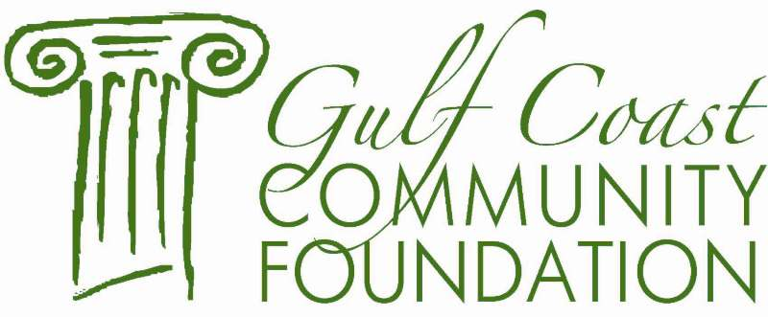

Jack A. Wilson Engineering

Scholarship Fund

The Jack A. Wilson Engineering Scholarship Fund was established in December of 2001 by Ms. Gertrude A. Wilson through the Gulf Coast Community Foundation to honor Mr. Wilson.

The purpose of this Fund is to provide scholarships for College, Junior College or Graduate school students entering their third or more year of engineering education. Students must be residents of Jackson, Harrison and Hancock Counties. Students meeting the criteria will be awarded a scholarship to be used toward the following, in order of priority: tuition and fees, room and board, books and supplies.

CRITERIA
In making its decision, the Selection Committee will use the following criteria:

- Enrolled in a College, Junior College or Graduate School
- Jackson, Harrison or Hancock County Resident
- Scholarship ability
- Good Academic Standing

GUIDELINES

- Completed Application Form
- Official College Transcript including standardized test scores
- A.C.T. and/or S.A.T. Scores
- Three letters of recommendation from one professor, one community leader and one individual other than a family member

Jack A. Wilson Engineering

Scholarship

Application Form

Name: __________________________________________________________

Address: ________________________________________________________

City: _______________________ State: _____________________ Zip: ______

Phone: ___________________________ Email: ________________________

School Currently Attending: _________________________________________

Field of Study: ____________________________________________________

Student ID:

Academics: College Grade Point Average _______________ ACT __________

SAT _______________ SATII _______________ HS Ranking ______________

(Attach official transcript)

List Honors/Awards and Special Endeavors: _____________________________

________________________________________________________________

________________________________________________________________

________________________________________________________________

List Community Service and Out of School Activities: ______________________

________________________________________________________________

________________________________________________________________

________________________________________________________________

List School Activities: _______________________________________________

________________________________________________________________

________________________________________________________________

Have you been awarded any other scholarships? If so, please list below.

________________________________________________________________

________________________________________________________________

________________________________________________________________

Attach a one-page essay explaining: Why you are motivated to seek a major in engineering? How do you plan to use an engineering degree?

Attach three (3) written letters of recommendation, one from a professor, one from a community leader and one from an individual other than a family member.

I CERTIFY THAT THE ABOVE INFORMATION IS ACCURATE AND PRESENTS A TRUE DESCRIPTION OF MY GOALS, TO THE BEST OF MY KNOWLEDGE.

Applicant’s Signature Date

APPLICATIONS MUST BE POSTMARKED BY

March 31st OF EACH YEAR

Please return this application along with requested attachments to the Gulf Coast Community Foundation for consideration.

Ms. Lisa Birmingham
Jack A. Wilson Engineering Scholarship
Gulf Coast Community Foundation
11975 Seaway Rd, Suite B-150
Gulfport, Mississippi 39503
(228) 897-4841 Phone

