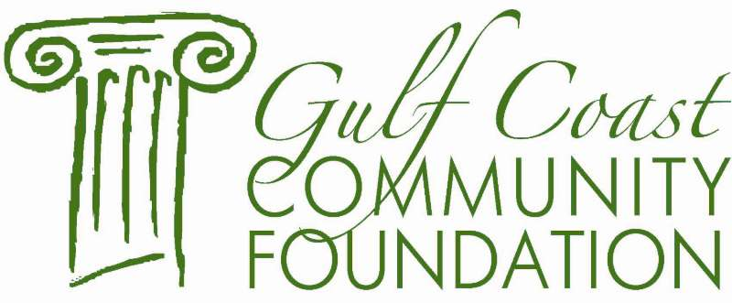

Grant Guidelines

PAT SANTUCCI EDUCATION FUND

Pat Santucci Education Fund awards grants annually to projects that impact public education and special education in Harrison, Hancock, Jackson, Stone, Pearl River and George County.
Deadline for application: October 31st of each year

Who Can Apply?

- Non-profit, tax-exempt organizations that are involved in enhancing the quality of life for citizens of South Mississippi.

- Organizations that have not been recognized as tax-exempt by the IRS may apply if they have a fiscal agent relationship with a 501(c)(3) nonprofit organization

- Public and private schools on the Mississippi Gulf Coast

- Organizations located in Harrison, Jackson, Stone, Pearl River, Hancock and George County

Awards are $2,000 or less not to exceed this amount.

