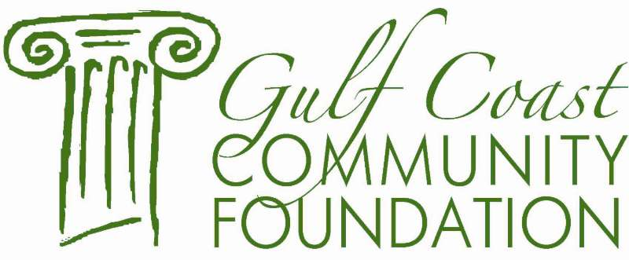

ANTHONY DARTEZ ENDOWMENT FUND

GRANT GUIDELINES

The Anthony Dartez Endowment Fund was established in April 1995 in Memory of Mr. Anthony Dartez. The fund is to provide grants for services including, but not limited to the training and educational needs of the physically and mentally challenged.

Who Can Apply?

- Non-profit, tax-exempt organizations that are involved in enhancing the quality of life for citizens of South Mississippi.

- Organizations that have not been recognized as tax-exempt by the IRS may apply if they have a fiscal agent relationship with a 501(c)(3) nonprofit organization

- Public and private schools on the Mississippi Gulf Coast

- Organizations located in Harrison, Jackson and Hancock County

Awards are $2,000 or less not to exceed this amount.

